**Experiment No. 8**

**Aim**: Perform and evaluate Frequent Pattern Mining Algorithms using any open-source tools

**Theory :**

Step 1: Install Weka: If you haven&#39;t already installed Weka, you can download it from the official website: https://www.cs.waikato.ac.nz/ml/weka/.

Step 2: Launch Weka: Open Weka and click on the &quot;Explorer&quot; tab, which is used for data preprocessing, modelling, and evaluation.

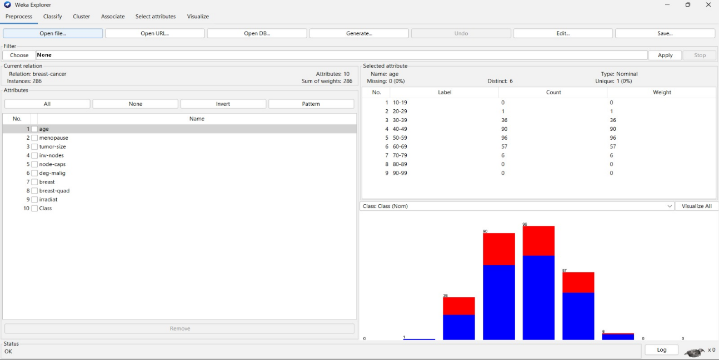

Step 3: Select the Apriori algorithm: In the &quot;Classify&quot; panel, click on the &quot;Choose&quot; button next tothe &quot;Classifier&quot; dropdown menu. Then, navigate to &quot;weka.Associations&quot; and choose&quot;Apriori&quot; from the list.

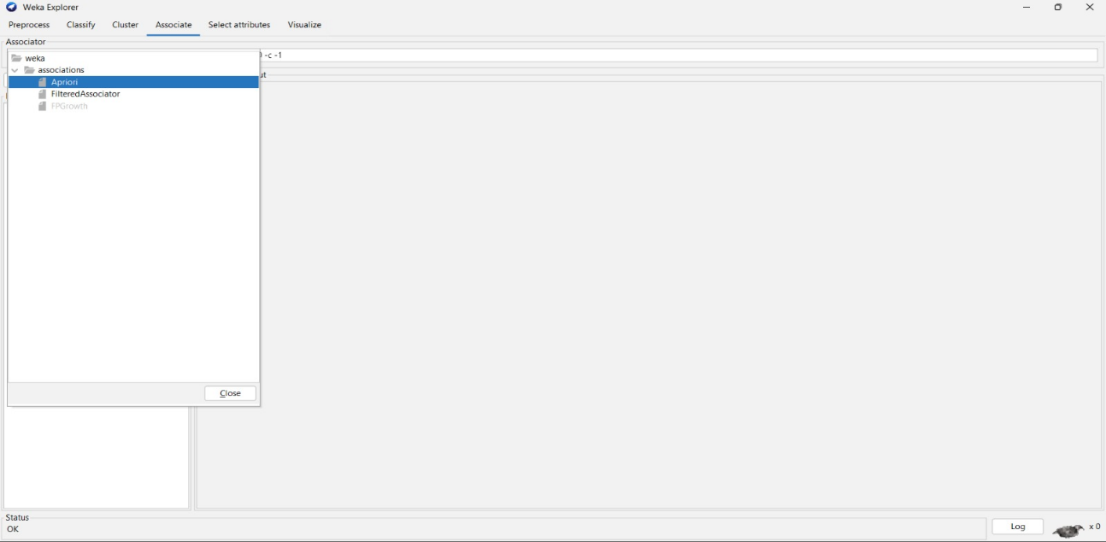

Step 4: Set minimum support and confidence: Adjust the &quot;MinSupport&quot; and &quot;MinMetric&quot;parameters to set the minimum support and minimum confidence thresholds, respectively.These values define the level of support and confidence required for an itemset orassociation rule to be considered frequent.

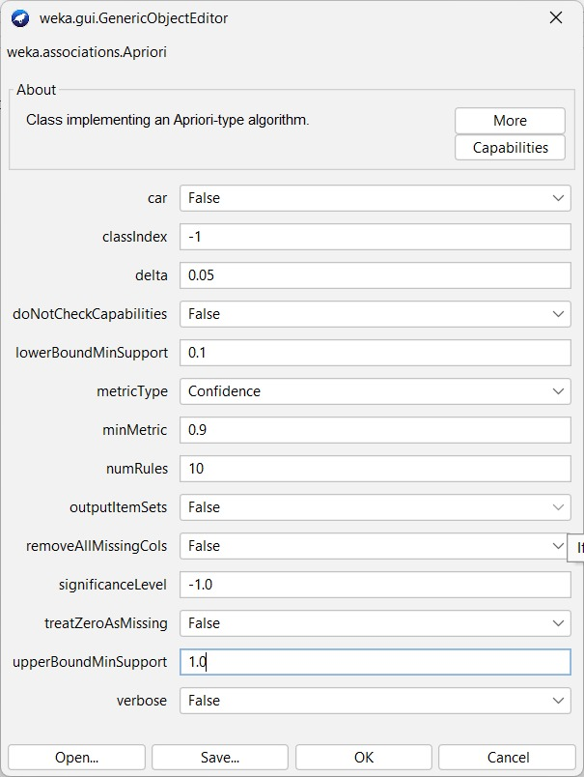

Step 5: Run the Apriori algorithm: Once you have configured the Apriori settings, click the &quot;OK&quot;button to close the settings window. Then, click onthe &quot;Start&quot; button in the &quot;Classify&quot;panel to run the Apriori algorithm on your dataset.

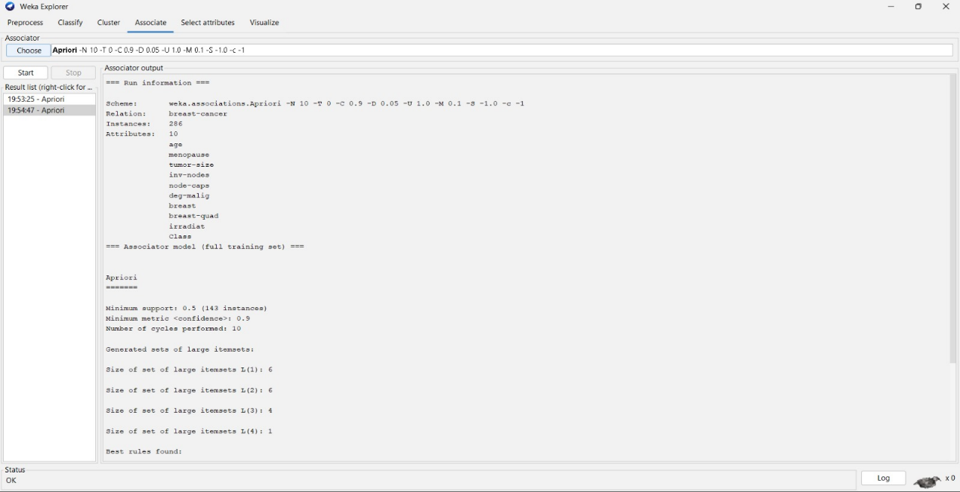

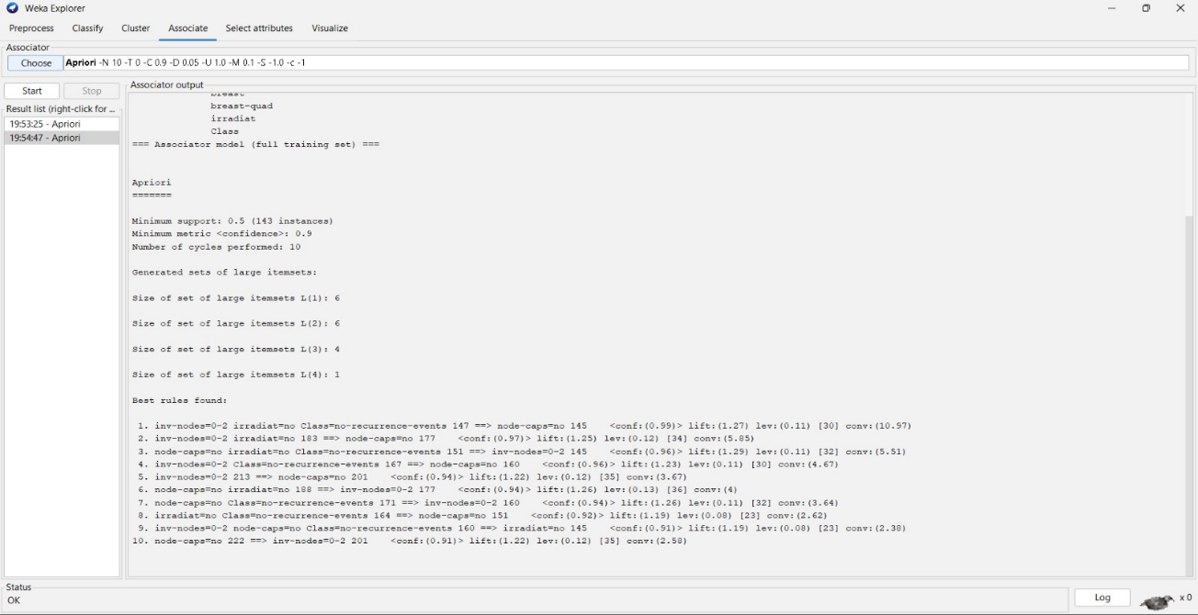

**Conclusion:Hence we performed Frequent Pattern Mining Algorithms using open source toolWEKA.**